
Milestone M9 Report
Title: Open Access Database of Program Blocks
WP7 - Implementation of Flexibility & Carbon Reducing Solutions in RIs
Reporting date: 19 June 2026

List of abbreviations:
Abbreviation | Definition | Abbreviation | Definition
AHU | Air Handling Unit | KER | Key Exploitable Result
AI | Artificial Intelligence | PLC | Programmable Logic Controller
BMS | Building Management System | RI | Research Infrastructure
CoDeSys | Controller Development System (IEC 61131-3 programming platform) | ST | Structured Text
HVAC | Heating, Ventilation and Air Conditioning | VFD | Variable Frequency Drive
IEC | International Electrotechnical Commission | WP | Work Package
JSON | JavaScript Object Notation

1. Summary
Within WP7, Task 7.1, ELI Beamlines has developed the first functional version of an open access database of BMS (Building Management System) program blocks optimized for RI (Research Infrastructures), supported by a code generation tool (#KER5). The principal milestone result is the public GitHub repository containing reusable AHU (Air Handling Unit) program packages.
The result addresses Milestone 9 by providing a structured basis for reusable BMS control algorithms. At the start of the project, the work was aimed primarily at high energy consuming buildings such as Research Infrastructures, where HVAC systems often serve cleanrooms, laser halls, laboratories and other controlled environments. During implementation, ELI concluded that the same open program block approach is also relevant for less specific but still energy intensive buildings, such as offices and advanced commercial buildings. The resulting stack of solutions therefore remains optimized for RI needs, but can also be transferred to a broader range of building types.
The original intention was to publish newly implemented or slightly revised BMS program code directly as an open database. During implementation, however, the consortium recognized an opportunity to provide greater value to users by creating a clearer, open-access GitHub repository containing representative AHU control packages, including technical documentation, Structured Text and Python code, visual schemes, and tool configuration files.
The tool for code generation workflow makes the database easier to extend and adapt. It can define an HVAC/BMS configuration, generate a machine-readable JSON (JavaScript Object Notation) file, visualize the selected equipment and produce control code. This does not replace the GitHub database as the milestone output; it supports the creation, maintenance and future expansion of the database. The tool is not part of this Milestone but will be accessible at the end of the project.
At this milestone stage, the database contains ten representative AHU configurations. The project plans to expand the repository until the end of the project to additional building-support technologies.

2. Background and rationale
Research Infrastructures often operate building technologies that are more complex and more demanding than those in standard commercial buildings. Cleanrooms, laser facilities, accelerator facilities, high-field magnet laboratories and similar environments require stable indoor conditions, precise control, high reliability and rapid adaptation to operational needs.
In many facilities, the BMS is implemented as a proprietary "black box". The facility team may have limited access to the actual control logic, while changes must be requested from the original BMS supplier. This can make optimization slow and expensive and can prevent facility engineers from fully understanding how the equipment is controlled, identifying inefficient behaviour, or quickly correcting bugs.
Table 1 summarizes the case that led to this solution in FlexRICAN: the transition from a former proprietary BMS approach to the assessed open program and hardware solution, including the practical benefits of open access to control logic.
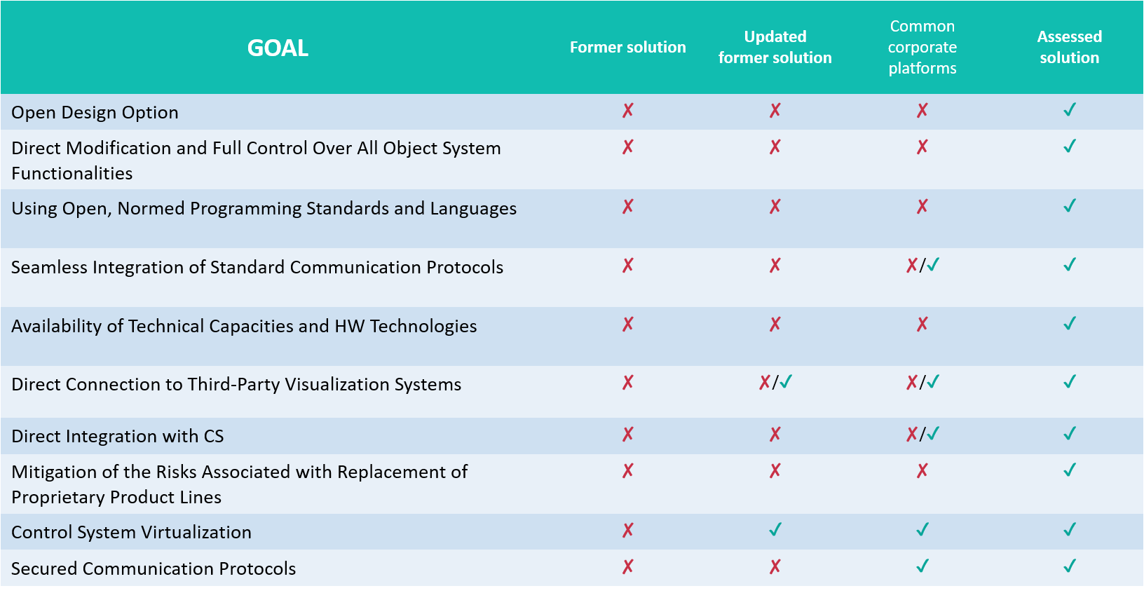
Table 1: Proprietary versus open solution for BMS.
FlexRICAN WP7.1 addresses this problem by creating open, documented and reusable program blocks for intelligent building management. The purpose is not only to provide source code, but also to provide understandable packages that RI technicians, facility engineers and BMS programmers can use to learn from, adapt, benchmark and challenge existing or supplier-proposed control algorithms.

3. Current status
The current technical result is the open access GitHub database of AHU program packages. Each package represents a reusable BMS control solution and includes the files needed to understand, adapt and implement the control logic. The GitHub database is the central evidence for Milestone 9; the code generation tool is a supporting method for creating and extending such packages, that is in Beta stage and will be provided at the end of the project.
For each program package, the database provide:
- a graphical representation of the selected AHU;
- IEC 61131-3 Structured Text code for CoDeSys;
- Python code;
- technical documentation and installation/operation guidance;
- a JSON configuration file.

The Structured Text code is intended for PLC/BMS implementation on CoDeSys-compatible platforms. The Python version mirrors the same control logic and can be used for simulation, training, testing, demonstration or future soft-PLC deployment. The JSON file serves as the machine-readable description of the selected equipment and contains the information required to generate code and visualization by the tool.
Scheme 1: Proposed generation workflow by the tool supporting the GitHub database.
One example package is a fresh-air AHU with water heating and cooling. It includes a supply VFD (Variable Frequency Drive) fan, intake and relief dampers, water heating coil, cooling coil, room temperature sensor, supply temperature/humidity sensor and return-water temperature sensor. The generated logic includes operating states OFF, STARTUP, RUN, SHUTDOWN, FROST, FIRE and FAULT; fan ramping; damper sequencing; cascade room-to-supply temperature control; split-range heating/cooling; frost protection; pump run-on; fan-fault supervision; sensor plausibility checks; fire response; and common alarm generation.
At the current milestone stage, the open access database contains ten AHU control packages in FlexRICAN GitHub. These packages cover a broad range of HVAC configurations relevant to Research Infrastructures, advanced technical buildings and more standard building types where transparent and energy-efficient BMS control is useful.
Table 2: List of AHU program packages in the database.
Block | Configuration type | Main function
AHU_01 | Supply/exhaust AHU with energy recovery | Supply and exhaust unit with heating, cooling and energy recovery.
AHU_02 | Dehumidification AHU | AHU extended with humidity and dehumidification control.
AHU_03 | Dehumidification AHU with water and electric after-heating | Dehumidification unit with additional after-heating.
AHU_04 | Exhaust ventilation with room-temperature control | Exhaust-only unit with room-temperature-based fan control.
AHU_05 | Fresh-air unit with energy recovery | Fresh-air supply/exhaust unit with heat recovery, heating and cooling.
AHU_06 | Fresh-air unit with electric heater | Supply-only fresh-air unit with electric heater and safety logic.
AHU_07 | Cleanroom recirculation AHU with HEPA filtration | Cleanroom recirculation unit with filtration and temperature control.
AHU_08 | Rooftop heating unit | Rooftop supply unit with water heating and frost protection.
AHU_09 | Rooftop heating and cooling unit | Rooftop unit with heating/cooling and split-range control.
AHU_10 | Fresh-air unit with water heating and cooling | Fresh-air unit with water heating, cooling, dampers, fan and cascade control.
The current version still contains some naming inconsistencies and spelling errors in working files. These are known issues and will be corrected during polishing before the final public release.

The generated program blocks include energy-relevant control functions such as cascade temperature control, split-range heating/cooling logic, deadbands, fan-speed handling and supply-temperature limits. These functions help prevent inefficient operation, such as unnecessary simultaneous heating and cooling, poor sequencing, delayed fault response or non-optimized supplier programming.
The main benefit of the database is that the program packages are not only code examples: they also include configuration files, visual schemes and manuals explaining installation and logic.

4. Conclusion
Milestone M9 has been achieved as an initial open access database of BMS program blocks, published as ten representative AHU program packages in GitHub and supported by a code generation workflow optimized for RI needs.
The database demonstrates the publication of JSON configuration files, Structured Text control code, Python reference code, system visualization and technical documentation. This establishes a practical basis for the final deliverable and for further exploitation of the result.
Validation status: at Milestone 9, the GitHub code packages have been reviewed through built-in scenario testing and human review, and the supporting tool was used to generate part of the code for new laboratories in ELI Beamlines in 2026; the next validation steps are testing on HVAC equipment at high-end apartment complex at Trigema and additional Research Infrastructures, including documentation of measured energy performance and operational impact.
Hardware and software considerations: the PLC hardware selection guideline is still under development, but the current approach assumes hardware that supports open programming and common BMS communication requirements, especially CoDeSys-compatible or equivalent IEC 61131-3 PLC environments and, where appropriate, Python-capable platforms. PLCs used in consortium are from Phoenix contact, Honeywell, Sauter and Siemens.
Open access and exploitation model: the GitHub repository and FlexRICAN website are planned as the main public access channels for the program packages, documentation, schemas and examples, while the AI-assisted generation service will remain a controlled supporting service with verified accounts because of computational costs, licensing of visual assets and the need to finalize the public licence model.
Further work will focus on public release, licensing, validation on different HVAC equipment, hardware-selection guidance and expansion of the database.

